145th Memorial Service in Green Hill Cemetery
761 Lee Street Danville VA 24540
At The Confederate Monument
Sunday June 4, 2023 at 3:00 PM
Presented by the Anne Eliza Johns Chapter UDC #164
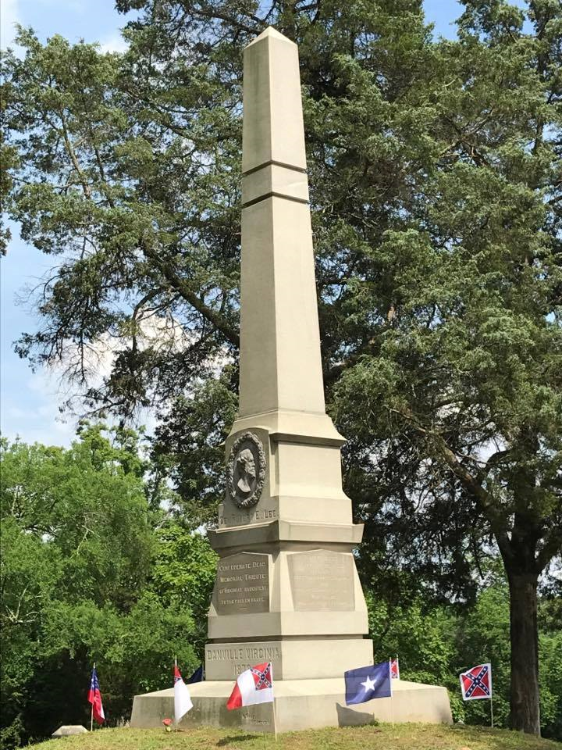
Speaker: Carolyn Winstead Bagley

Honor/Color Guard: Stuart-Hairston Camp 515 SCV &
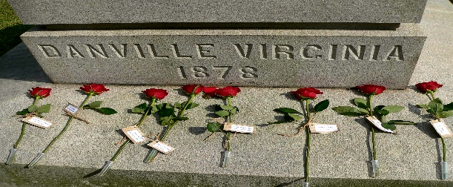
18th VA Reenactors
Honoring 145 years of gathering
at the monument

*Please Bring a lawn Chair

